Funny how things go eh!?

I was in no doubt that this whole crazy trip of mine would generate opportunities and experiences. If sailing the wrong way across two oceans isn’t enough, I’ve been fortunate to experience many things that will remain with me for a lifetime; Christmas in the tribal village of Manjumba 130Nm up the Gambia River, driving the tug boat in Saldhana, mountain biking on a volcano in the Canary Islands, co-presenting a radio show in St Helena with Zac Sunderland, on stage with the Parlatones and others at New Year… and so much more. For the past four months though, I’ve been fortunate to experience something that, as someone who set out to sail around the coasts of the world, I could not have dreamed would form part of my adventure… I have been on a private Game Lodge in the Kruger National Park.

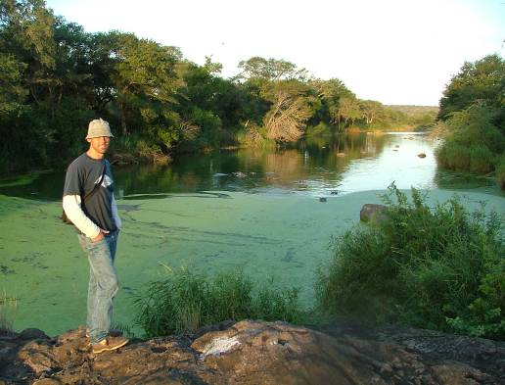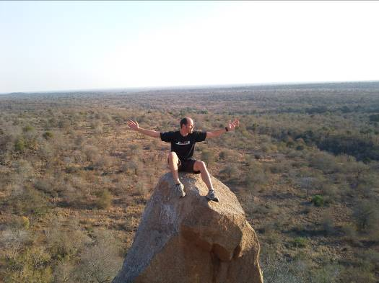

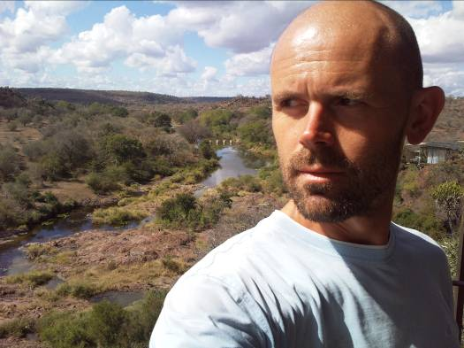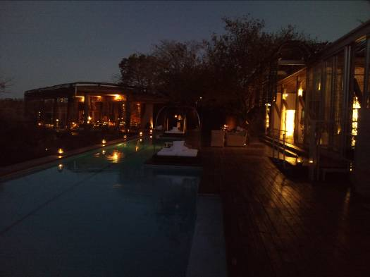

Okay, so I was there with my good friend Jacek to work. And in fact, we did work – hard – most of the time. We were tasked with renovating the main pool deck area and replacing the shower floors in each of the twenty-one units. It was supposed to be a three-month project but because the lodge was often full to capacity, and we were unable to work, the project took just under four months to complete.

It wasn’t all hard grafting though – far from it. It’s hard to know where to begin but in that time, whilst living in one of Africa’s most exclusive lodges (R11,000 per person per night!), I got to go mountain biking through the bush, to track lions on foot, to enjoy regular game drives and, well, to party! Oh, and did I mention that Jacek and I even escaped over the border to Mozambique… twice! Sounds tough eh?

I’ll be honest, I’d never really been passionate about wildlife, about ‘the bush’ or the ‘khaki shorts’ lifestyle. Not because I don’t care but because I’d never really given it much thought. I’m an Englishman and as such, it’s just not in my genetic coding. Jacek told me he’d quoted on a project in Kruger and I had half-heartedly joked with him that he’d obviously need some help with it. Well why not? As much as anything, I needed the money but I was intrigued by the idea and in the true ‘W2N’ spirit of my new carefree bohemian life, I thought the contrast would be refreshing. Well, that was four months ago – almost exactly, and I must tell you that having spent so much time with the ‘khaki shorts’ fraternity, I too share their passion for the lifestyle, for the animals, the abundant wildlife and the isolation of living and working on a Game Lodge.

I’m back in Knysna now and, in fact, very happy to be back, but I will remember my time at Singita Lebombo for a lifetime. Yes, of course, the most extraordinary experiences involved animals, or ‘game’ (to use the generally accepted term!), but it wouldn’t have been nearly as much fun were it not for the people – the Singita staff. They made us so welcome from the first day to the last and their passion for life in the bush is infectious. Every day, there would be talk over lunch or dinner about the leopard sighting, the buffalo kill, the rhino encounter or the lion spoor found inside the camp. Occasionally, we’d be invited to go with them on game drives late into the night and were rewarded with some extraordinary sights; male lions within arms-length, a leopard with her two cubs, huge rhinos, elephant breeding herds scratching at the dry riverbed for water to drink and dozens of hippos. There were even some chance encounters when we least expected them; a herd of at least four-hundred buffalo coming to drink at a lake, two cheetahs stalking a herd of impala (unsuccessfully!) and a leopard crossing the main road right in front of the car. Oh, and I should mention that the Kruger National Park is not a zoo. It is vast. It takes three hours just to drive from the lodge to the gate and then the nearest town is another hour at least but there are no fences and whilst sighting a lion or a leopard or a buffalo is not guaranteed, when you do, it is behaving perfectly naturally. That of course means that if it’s not trying to mate something, it is probably trying to eat something – and that’s what makes it real, fascinating, compelling.

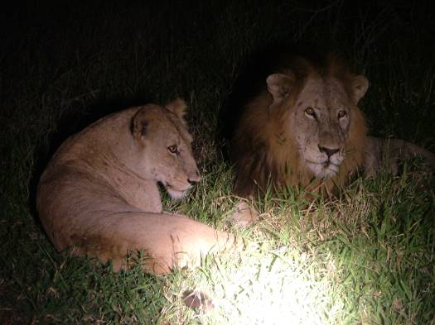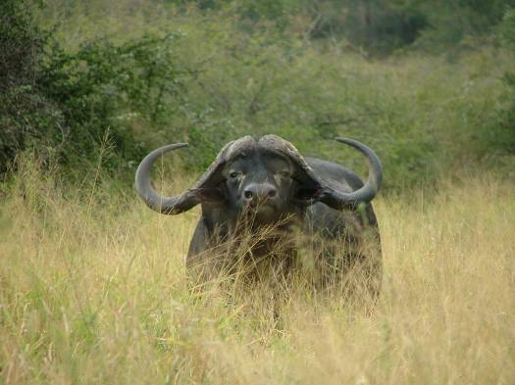

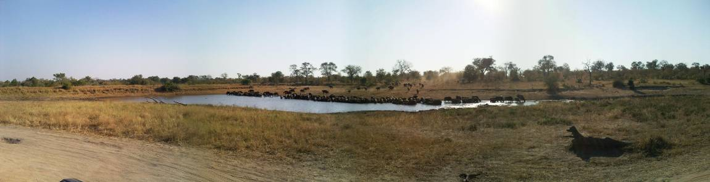

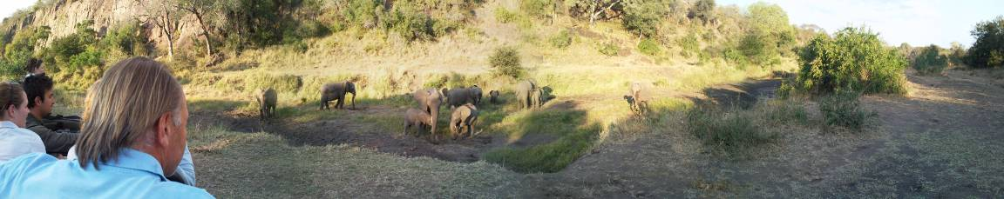
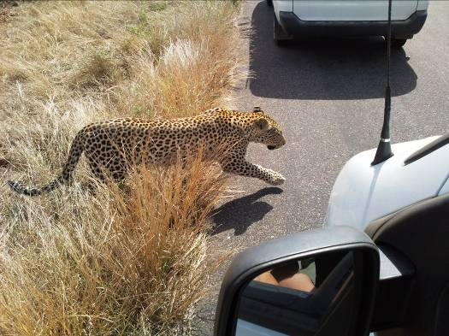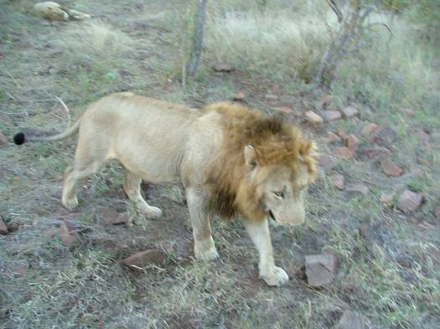

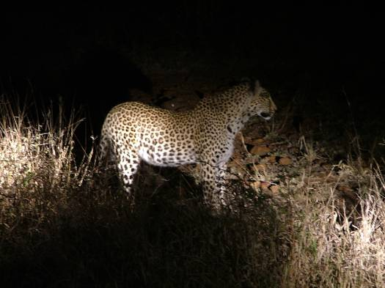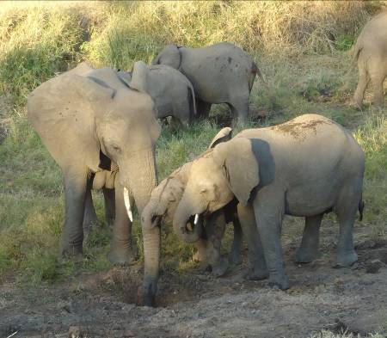

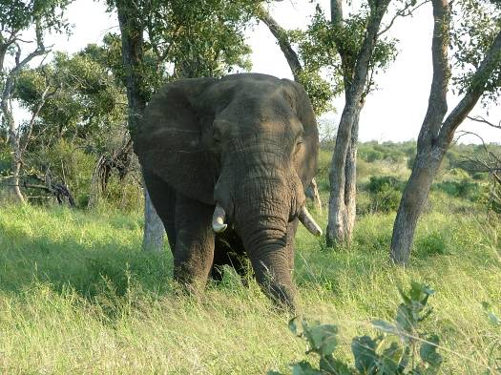

Lion, Leopard, Cheetah, Wild Dog, Hyena, Waterbuck, Impala, Kudu, White Rhino, Elephant, Buffalo, Hippo, Wildebeest, Zebra, Crocodile, Water Monitor, Rock Monitor, Lizard, Gecko, Snake, Monkey, Baboon, Genet, Bushbaby, Honey Badger, Giraffe, Warthog, Fish Eagle, Bateleur, Vulture, Kingfisher, Hornbill…

There’s more – lots more – I just can’t remember them all. Early one morning I took a call from reception to suggest that we shouldn’t walk from the M’Wanetsi staff village to the main lodge as a pride of lions had been spotted inside the main gate. In fact, what she said was “If you are walking to the lodge, please be careful – there are lions…!” Another morning, I walked within a few metres of a giraffe beside the path just outside of our staff village. In fact, a pair of giraffes were often in or around the staff village or up by the generators where Jacek and I kept some of the woodworking tools. On one mountain bike ride with an armed ranger we were following a game trail and came face to face with a rhino. As we worked, daily, hippos would be constantly making that extraordinary grunting noise in the river valley below while Fish Eagles were screeching above. The sounds of the bush are bizarre… and constant.

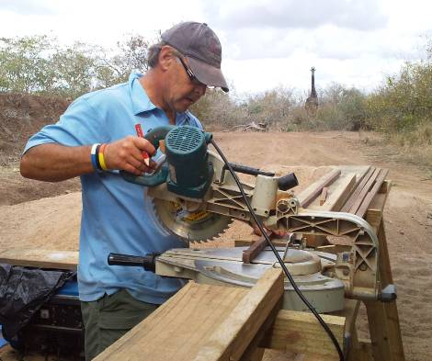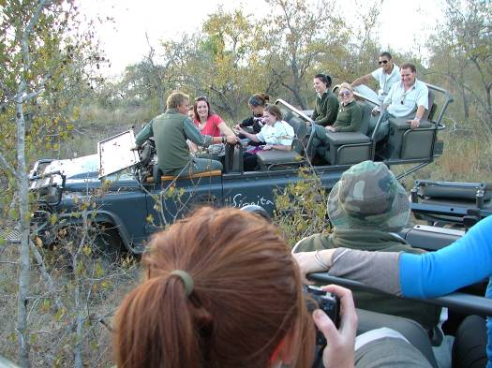

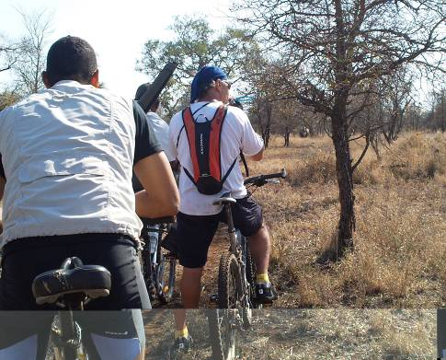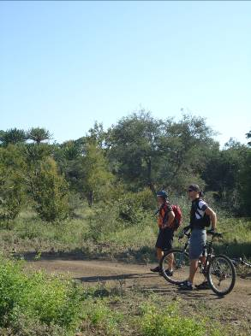

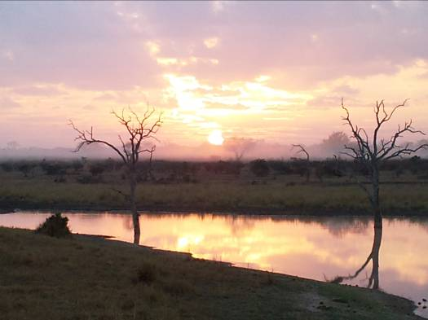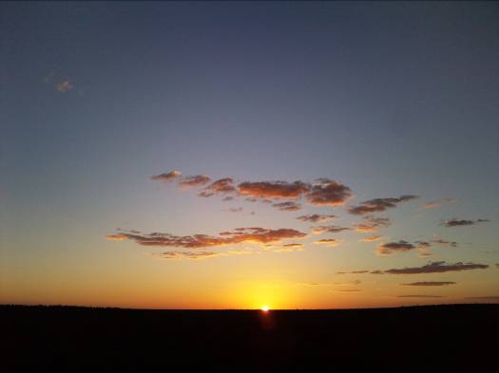

So, what more can I tell you? In four months I’ve had an unbelievable adventure. I’ve made so many new friends and I’m told our work is very much appreciated. In fact, Jacek has quoted on several other projects which, if approved, may mean that I’ll be invited back but… and it’s a big ‘but’… I cannot even begin to tell you how exhilarating it is to be back in Knysn; back to KYC, back to Canasta and above all, back with my lovely Jo. Yes, I know, it sounds soppy but Jo has been incredibly patient with me and being away from her for so long was always going to be a huge strain on our relationship. It’s a shame that she couldn’t spare the time to come to the lodge – she’d have loved it but one day I will take her there. Well, when I say ‘there’, I do of course mean ‘the Kruger Park’ generally and not necessarily the R11,000 Singita Lebombo private game lodge! Jacek and I raced back from the park in time to celebrate KYC’s 100th birthday celebrations. Since I’ve been away, KYC has completed and opened the new ‘Asches Cabin’ bar and I have to say, it is absolutely beautiful. When I left, there was a degree of negativity about what was believed by many to be a huge waste of money. I too thought that the Asches Cabin investment could have been a new fleet of boats for the juniors but you know what – I was wrong – it is stunning. The centenary celebrations were a triumph for the club and I was so proud to be part of the classic boat sail-past on board my friend Dudley’s lugg-rigged boat Iris – a locally built Acorn. Jo sailed with me as we followed the leading boats past the quarterdeck to salute the commodore with over one hundred boats, new and old, in our wake. I’m told there were 147 boats on the water (or thereabouts) and as you can imagine, it was quite a spectacle that wasn’t without incident!

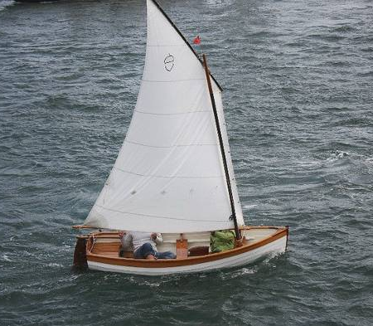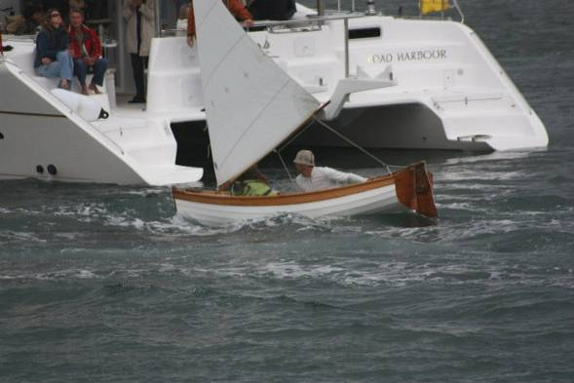

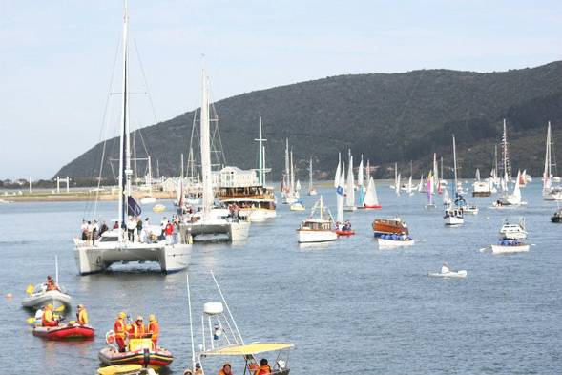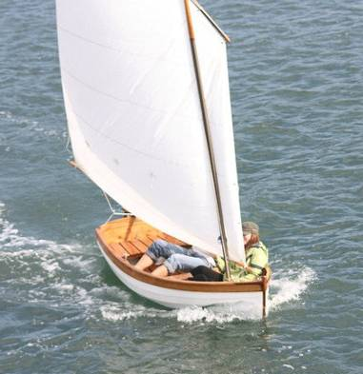

So that’s just about it from me for now. I’m getting back into the coaching and have signed up to become an ISAF qualified instructor. I shouldn’t have any problems extending my volunteers visa in November and as such, have absolutely no intention of leaving Knysna any time soon – if ever. Only this morning, the first time I have woken up on Canasta since returning from the bush, I watched the sun rise across a misty lagoon and realised what an idyllic life I have here. Canasta is in the queue to be hauled out for routine maintenance but is otherwise in great shape (if a little dirty from four months of neglect) and I have signed up to compete in the ‘Karoo to Coast’ 100km mountain bike challenge on 19th Sept. Well, I splashed out on a rather extravagant mountain bike just before leaving for the Kruger and the ride through the Karoo and along the Prince Alfred’s Pass to Knysna is perhaps some of the most spectacular and exhilarating scenery imaginable.

So that’s it. I’ve been working hard…

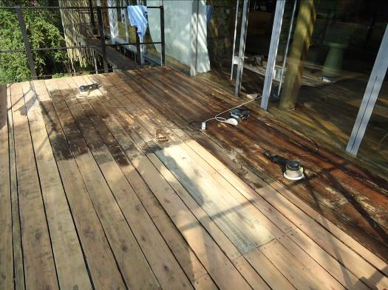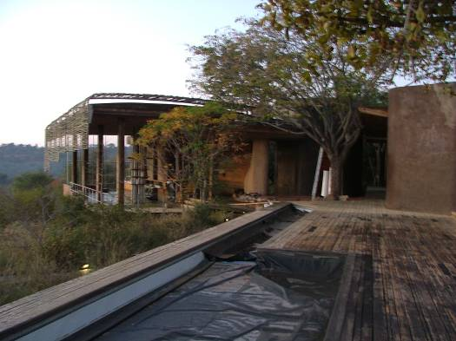

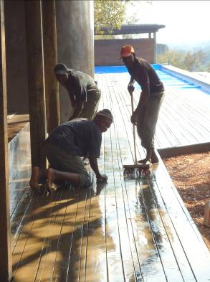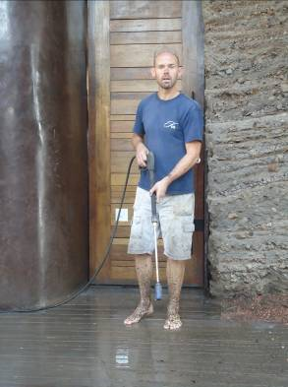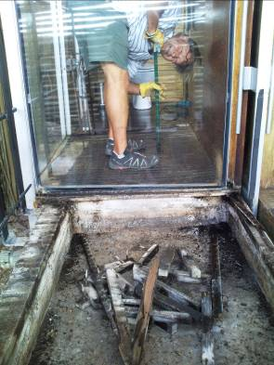

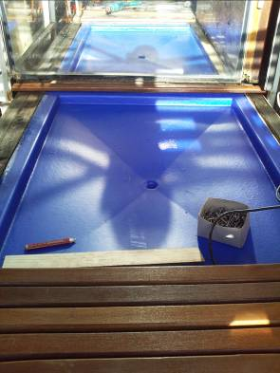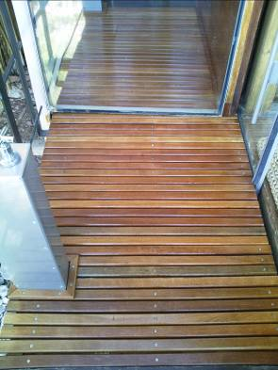

… but not all the time!

