Missive 2007-1 Greetings from the boatyard in Ecuador.
October 21:

This is the first Sunday of our labors on Otter for the season. The push this session is to replace the wooden and steel bumpers on each side of the boat, their function being to protect the paintwork from horny docks and imprecise skiff drivers.

After returning from Scotland, (two week trip with my Dad), there were a couple of days to get organized including a Wake and an Anniversary. We drove the car south this year, the boat being too far to drive the truck and camper as was usual, stopping to visit family and friends in California. A car park was found in Las Vegas and an early flight out of there ended around midnight in the big scary city of Guayaquil.

A 3 hour taxi ride next morning and we arrive at Otter and begin to survey all that must be done to get her ready for sea.

She is a filthy mess despite being parked bow to the sea only 30 feet away. All the stainless is stained and the hull showing a disheartening new crop of blisters through the grime. The yard dogs have over tightened a couple of the stands which have dished in the sides somewhat and the Genoa is still bent, meaning the sail that was stuck on the forestay which I had paid the local rigger to fix remains unfixed.

We set to. Phyllis wades in to get the deck washed and I tackle some of the chores left over from last season that could only be fixed with smuggled parts from back in the world. The inverter had to be changed and the house water pump. The engine had to de de-inhibited and made to run; a not by any means sure thing as extensive and sorrowful past experience can attest. On shutdown in January I had drained and flushed all fluids, changed the oil, pulled the injectors and dumped fresh oil into the cylinders all in a heartfelt effort to avoid the dreaded seized engine syndrome enjoyed 2 seasons ago when a few drops of water had dripped into #3 cylinder over the summer and rusted the piston to the bore engendering the second overhaul in 900 hours of running.

All went well and we are now organized to embark on the major job of removing the 122 bolts which hold the rails onto the outside of the hull. The boat has to be gutted to get at the nuts on the inside of the hull. All the cabinets and contents have to be shifted and piled willy nilly here and there. Tests at close of last season showed that it is impossible to hammer out the heavy bolts as they have corroded in place in the 28 years since they were glued in and the cabinetry is too tight to allow any swing with a hammer for most of them.

We brought an air hammer south with us which did the trick, a nice little compressor bought locally provided the air. Inexplicably, though this is really a nice boatyard, services like air and power to each boat stand was not deemed necessary by the planners. It still took over a half hour of work for us to remove each bolt.

I had hopes for salvaging much of the teak the rail had been constructed with but once apart most of it could be gouged out with a finger it became clear that new wood would have to be found. There are woodyards aplenty but the custom here is to buy your wood from the yard and let it lie under your shack for a year to lose some of its raw greenness.

We carried a sample chunk and located a furniture manufacuary and its young proprietor, Rene. He seemed sanguine about the job and took 30 dollars for more wood, all dry he swore.

The next visit found him industriously grinding out copies of only one of the pieces we had provided, not making a copy of each hunk. Lost in translation it appeared. Back on track he promises to have it all done prior to the multi-day holiday of The Day of the Dead where not one bit of work gets done anywhere in the Spanish and Portuguese world for days.

Back on the appointed hour he is all done but not all is right. Very little is right actually, a highschool shop would have done better. The wood is good though so we packed it all up and hailed a passing delivery truck (the usual practice here) and head back to try and make it work.

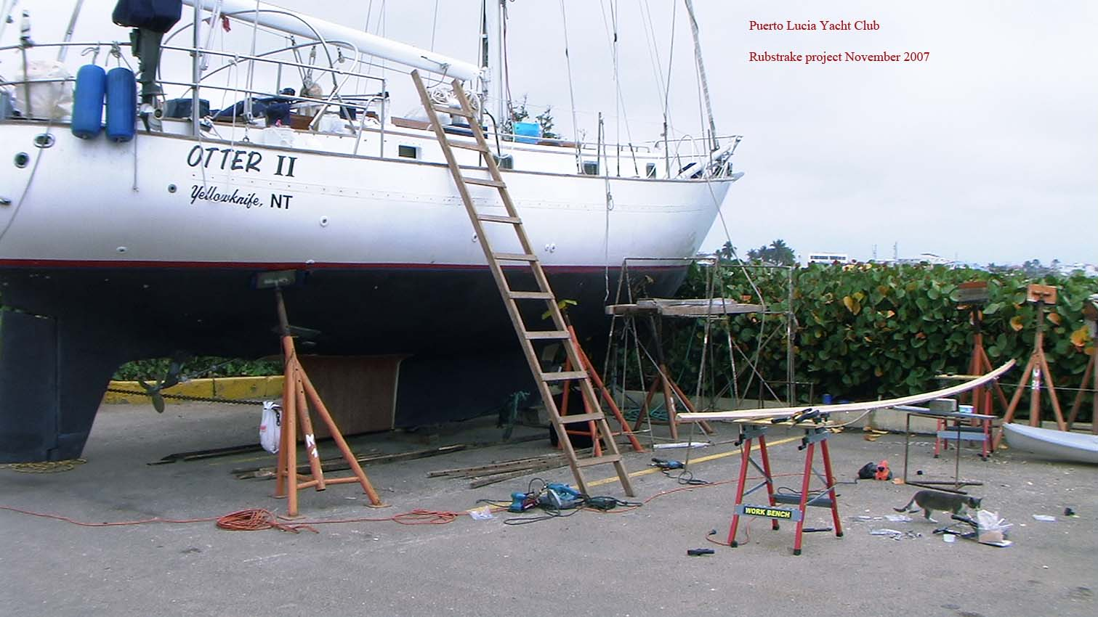

Meanwhile I have had a meeting with the marina manager and he has good news that boats here prior to April are not to have the new draconian customs rules applied so he can depart whenever without more than the usual hassle. It will cost some 300 bucks to check out but at least we do not have to waste a day racing all over town to complete the paperwork ourselves.

The weather is not at all what one might assume to hold sway right on the equator. It is uniformly overcast grey and misty just like November back in BC. The freezing Antarctic water which flows north on the Humboldt current brings Chile to us. The temperature is good for working at 25 degrees max.

Monday November 12.

Today we finished the rails and are taking the afternoon off to celebrate. There is a potluck dinner tonight as well. There is not that much socializing in this yard, not many here and everyone is tunnel visioning in getting out of Dodge.

In the next couple of days we will finish the bottom and fitting up for sea and then head off for a two week road trip upcountry to Quito then to Peru to visit Machu Picchu.

Our whirlwind trip around Ecuador and Peru was a good experience. We started off by bussing to Guayaquil and then flying to Quito for a 3 day visit of the city and its environs. We are pretty savvy travelers so all went well. The only awkward bit was on departure from Guayaquil in an old 727-200. When they ran up the power the center engine stalled with quite a bang. We came to a stop and I expected we may taxi off when 1 and 3 were brought up and then 2 (the center one) was brought in slowly and we departed without further drama. They were obviously used to the procedure. I was glad it was on a sea level departure and not at 9500 ft as it would be departing Quito.

The approach at Quito is interesting as the airport is right in the valley of the city of 1.5 millions and the approach must be flown much faster than normal due to the altitude. Two days prior to our arrival an Iberia 340 ran off the end of the runway in a very similar fashion to the Air France one at Toronto. We had a good look at its forlorn tail sticking up into the air off the end on the runway as we taxied off.

The altitude made me feel a bit short of breath at night but the acclimatization proved to be a boon on the next leg on the journey; Peru and the sacred valley where the ground starts out around 10000 ft above sea level.

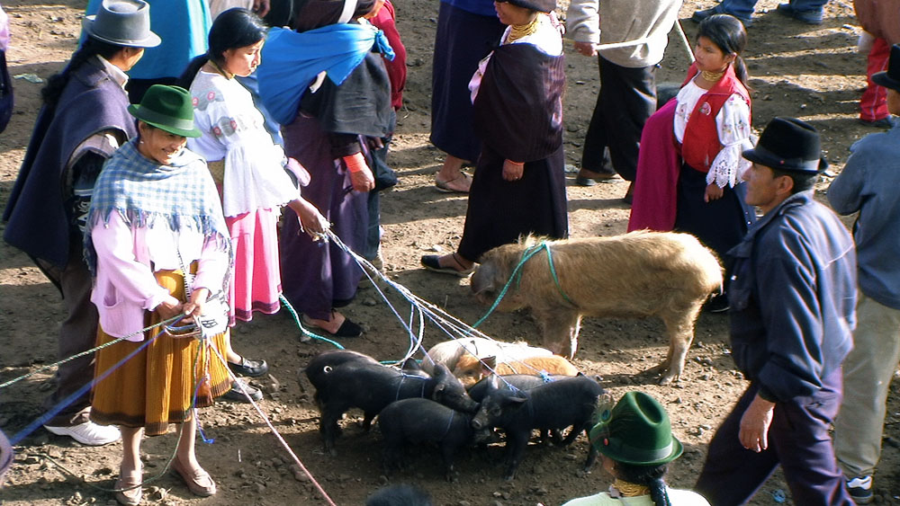
Figure 1: The animal market at Ortovalo north of Quito

We flew to Cusco (capital of the Incas) via Lima and arrived to meet Phyllis’s sister Lillian and her two sons.

There followed a pretty rigorous tour of the Inca ruins in the vicinity including Maccu Picchu. The first visit was to the fine rambling complex at Pisaq which entailed a 2 hour bus ride and a 4 hour hike. The trails were all but vertical and the un-guard railed drop off the edges up to 1000 meters. The workmanship on the stonework had me enthralled from the start. Closely fitted without cement, many have stood 700 years and who knows how many earthquakes and still a knife blade cannot be fitted between the stones anywhere along the wall. The wall, whose obscure function will never be known, eternally hanging over a vertigo inducing abyss.

Other ruins over subsequent days gave plenty of scope for enjoying stunning views and fine stonework along with calf shivery workouts.

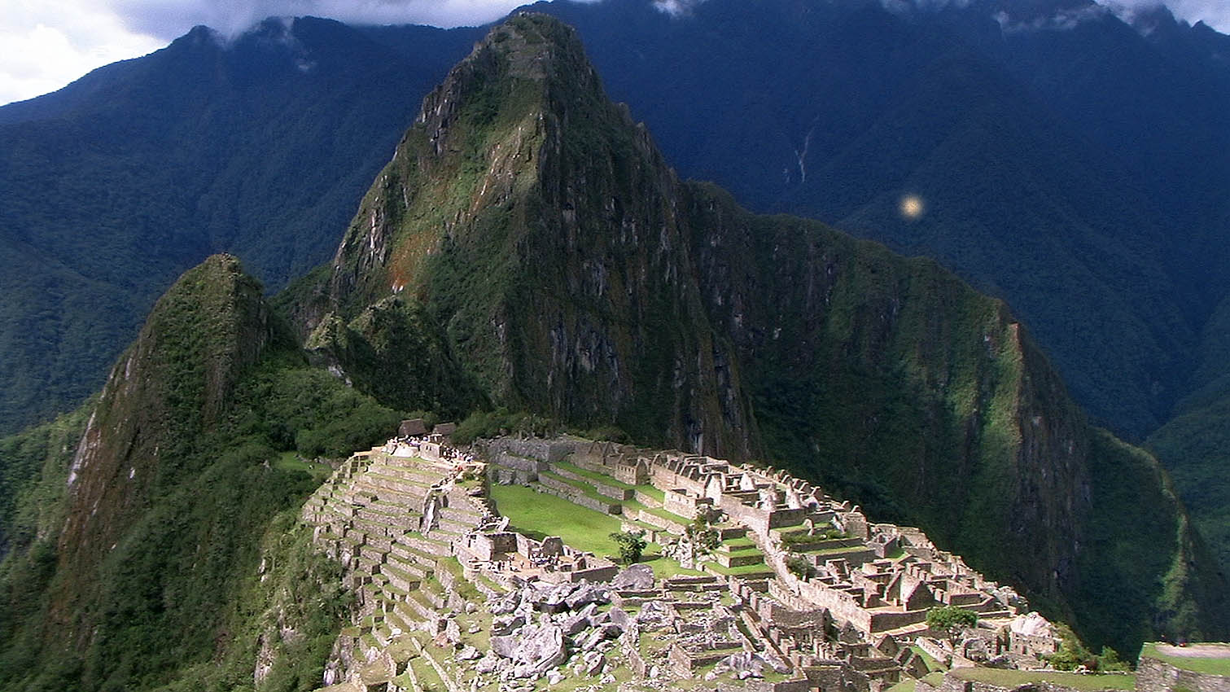
Figure 2: The classic Macchu Picchu shot.

Maccu Picchu is in a league all its own of course. It is one of the ‘7 wonders’ and deserves its position more than many of the others. We have all seen the classic photograph of the site but that does not do it justice as to just how extensive it is. The stonework (to the nascent expert) at least, was not up to par with many of the other sites except for the temple areas. The attraction here is the remote location which includes a bus and train ride to access and its unsullied condition due to never being located by the rapacious Spaniards. Much of the site just has to be thatched over and it can come to life again.

We spent two days on the site the first sunny and the second rainy. The second day was mostly consumed climbing the tall rocky spire featured in the classic picture. A very interesting climb which would require rope and pitons were it not for the steps laboriously hacked from the living rock with stone and bronze tools.

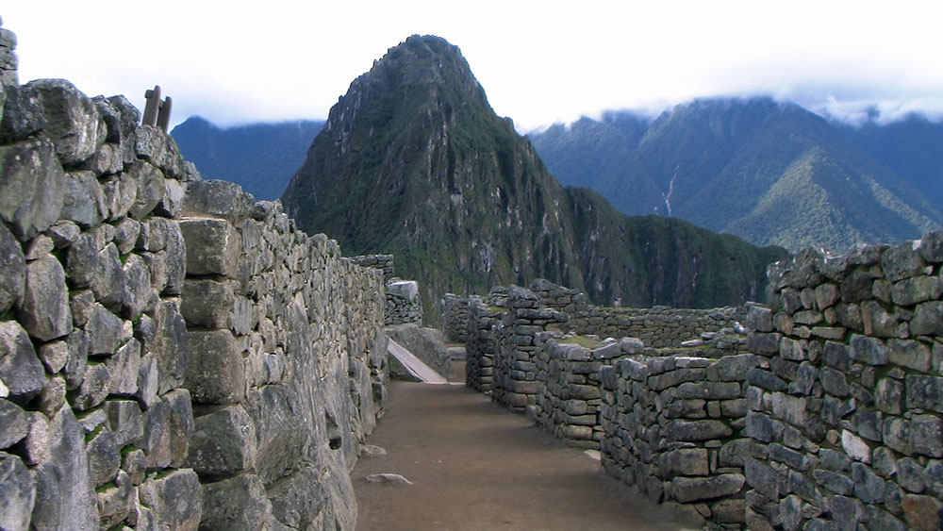
Figure 3: Walking around the extensive ruins

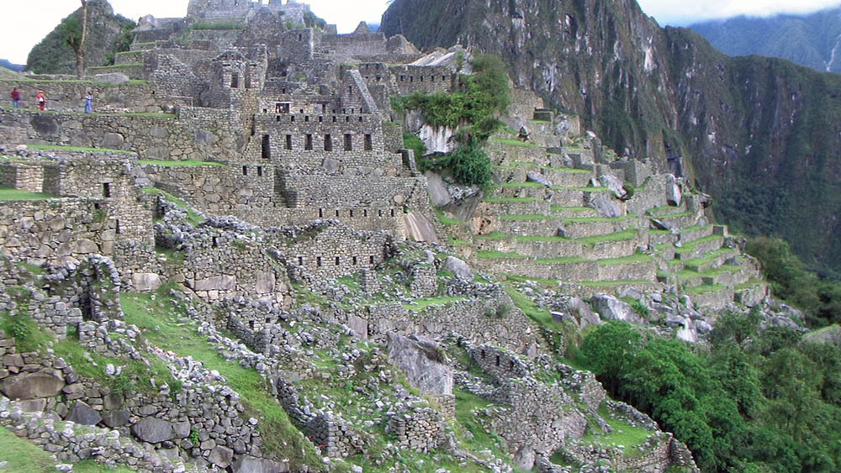

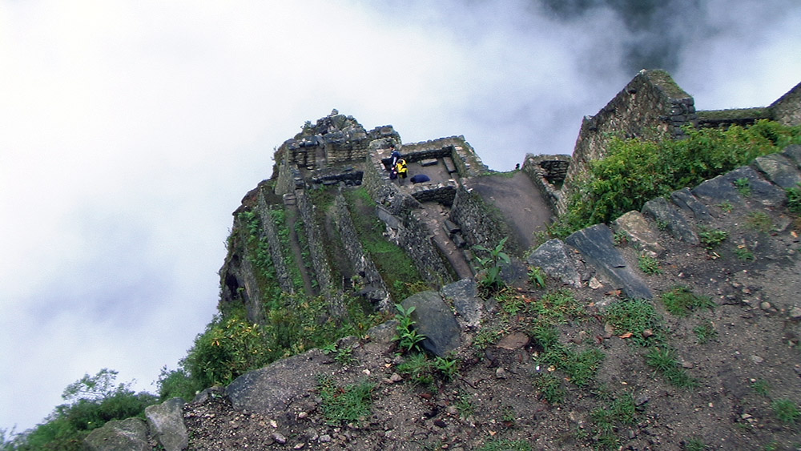
Figure 4: View down to the valley from the top of the pinnacle

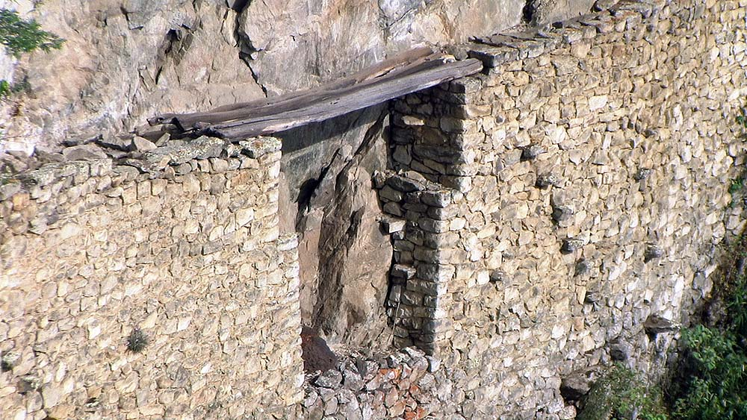
Figure 5: The Inca drawbridge on the alpine trail heading south

Visiting done it is time to return to the boat get her launched and head off to Panama. First we had to cross the worst border in South America, that at Tumbes, Peru. As our trip was kind of short notice, we could not fly all the way north to Guayaquil so we flew into the north Peru border town of Tumbes and had a plan to catch a bus north. At the airport we were greeted by a couple of grifters who had a story and a plan to get us across and extract some cash. We went with a couple of guys who had official looking Taxi ID and a pretty fair vehicle. Their story was (near as my Spanish could decipher) was that the bus was out due to a banana workers strike which was due to start tomorrow. We had to cross tonight with them. OK; we negotiated exactly what it was going to cost ($30) and exactly what the program was to be. They would take us the 30k to the border, stop at the Peru customs post to have our passports stamped out and then escort us over to the Ecuadorian side to a waiting bus and incidentally check into Ecuador at their customs post. We had read quite few horror stories about people being taken for rides and having various extra fees extracted up to 500 dollars and more but we knew there was no fee to check out of Peru and none to check into Ecuador so all we were going to pay was essentially the taxi ride. We departed about 1730 with enough daylight and were prepared to intervene physically if there were any sudden detours. We after all outweighed the two guys by over a hundred pounds and were obviously alert.

All went as described. Of course the customs offices of either country were nowhere near the border. Without a guide it in the dark in the very scary locales of the offices we would have been hard pressed to make the 2000 bus. The actual crossing of the border was on foot across a noisome stream through some very nasty neighborhood, there being no check point at all.

The service was as described and we made the bus so I gave them a 20 dollar tip; two days wages around here. The strike story was a fabrication as we suspected but we rightly judged that the story was to keep us in their hands and not some competitor’s, not to set us up for a robbery.

Dec 02

We are afloat and all is serviceable (for now). The only problem after launching was a leaky raw water pump for which we had a spare. 4 hours to take out 4 bolts and fit the new one.

The marina here has no pilings. All the docks are floating on old plastic barrels with aluminum struts attached to the bank holding things precariously. The marina itself is an L shaped pile of rocks sticking out into the otherwise unprotected open bay which means the remnants of the often large ocean waves curl around into the entrance causing considerable surge. The shore side is undeveloped with docks as of yet so it is possible to “med moor” which means tying the boat bow and stern with the bow pointing to the shore. A little inconvenient to have to take the dinghy the 40 ft to shore every time but much more comfortable (and 30 bucks a day cheaper) than the docks which thrash back and forth all day in the surge.

We have completed provisioning; everything needed for a month or more is tucked away below. Tomorrow the agent should show up with our exit papers and we are gone. I am sure he will show up eventually as we owe him 100 dollars for fuel he scrounged for us.

Fuel here is subsidized. The locals pay 1.03 a gallon for diesel and 1.33 for gas. The problem for us is it is not legal to sell damn foreigners the cheap fuel (the marina had its pumping privileges suspended for doing so) so it has to be smuggled into the yard.

Ecuador is awash with oil. This is a rich country, at least theoretically. There is an oil transshipment facility 5 miles east along the bay which is always busy.

I do mean awash as natural oil seeps out of the rocky shoreline nearby to leave rainbow smears on the surface.

On the weather side summer is here. The sun comes out here December 1 just like clockwork. There is a nice favorable wind for heading north too.

14:00
Our agent just came by with a pack of papers for me to sign so it appears we will be leaving. There was no talk of being in the country longer that allowed, no extra fees or fines, so far.

The next blog will not be until January if all goes well we are going to hide out until then in the Las Perlas Islands in the Gulf of Panama.

Best Wishes for Christmas and the New Year to ALL….

Bruce and Phyllis.

Our Blog site is at http://blog.mailasail.com/otterii

